Putnam Valley Day Camp Activity Calendar July 2014
Monday | Tuesday | Wednesday | Thursday | Fun Friday
30  Welcome to Camp!  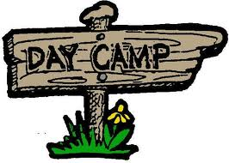 | 1 | 2 | 3 PVDC  BLOCK PARTY!  Dress up in Red, White & Blue!  (BBQ Lunch will be provided) | 4  Happy 4th of July!  No Camp  
7 | 8  Teen Travel: 6-10  Splash Down  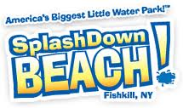  Kidz Encounters: K-5 | 9  Unbirthday Party!    Dress in bright colors | 10 | 11  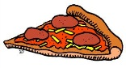Pizza Friday
14  Teen Travel: 6-10  Hudson Valley Renegades    Kidz Encounters: K-5 | 15  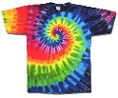  Tie-Dye Shirt Day-Send in a plain white LABELED T-shirt in with your child | 16 | 17 ColorWars!  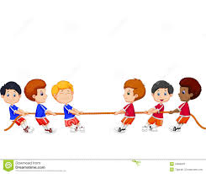  Dress up in your team colors | 18  Pizza Friday
21 | 22  Wild Wild West Day!    Dress in Cowboy & Indian Attire | 23 | 24  Teen Travel: 6-10  Roller Magic  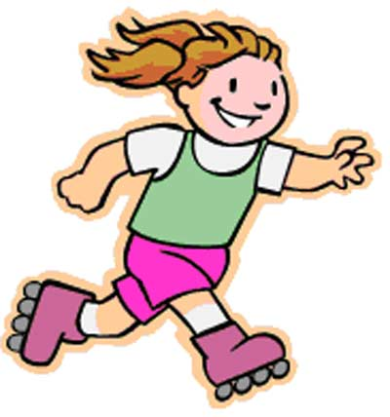  Kidz Encounters: K-5 | 25  Parent Day: Carnival  (Pizza Friday for children only)  
July 28 | 29  Teen Travel: 6-10  Rocking Jump    Kidz Encounters: K-5 | 30  Wet and Wild Day!    Dress up in swimwear attire | 31 | 1  Pizza Friday
Putnam Valley Day Camp Activity Calendar August 2014
Monday | Tuesday | Wednesday | Thursday | Fun Friday
4 | 5  Pirate Paloooooza!  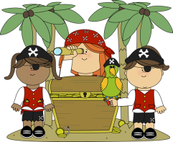  Dress up in pirate attire | 6 | 7  Teen Travel: 6-10  The Castle  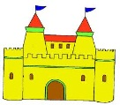  Kidz Encounters: K-5 | 8 Pizza Friday  (For children only)  Parent Day: Olympics!  Dress up in your country colors
11 | 12  Teen Travel: 6-10  Canopus Lake @ Fahnestock State Park    Kidz Encounters:K-5 | 13 | 14  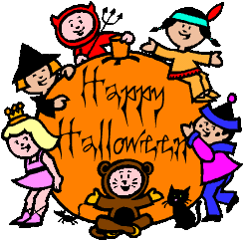  Halloween!  Dress up in your favorite costume | 15  Pizza Friday
18 | 19 | 20 Camp Luau!    Dress up in your Hawaiian attire | 21 | 22  Pizza Friday  Last Day of Camp!

