Putnam Valley Day Camp Activity Calendar July 2013
Monday | Tuesday | Wednesday | Thursday | Fun Friday
24  Welcome to Camp!  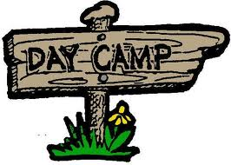 | 25 | 26  Pajama Day   | 27 | 28  Wild Wild West Day  
1 | 2  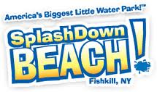  Teen Travel: Splash Down  Special Activity for Younger Campers | 3  Las Vegas Day  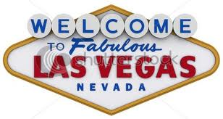 | 4  Happy 4th of July!  No Camp  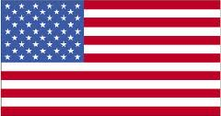 | 5  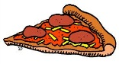  Pizza Friday
8 | 9 | 10  Tie-Dye Shirt Day   | 11  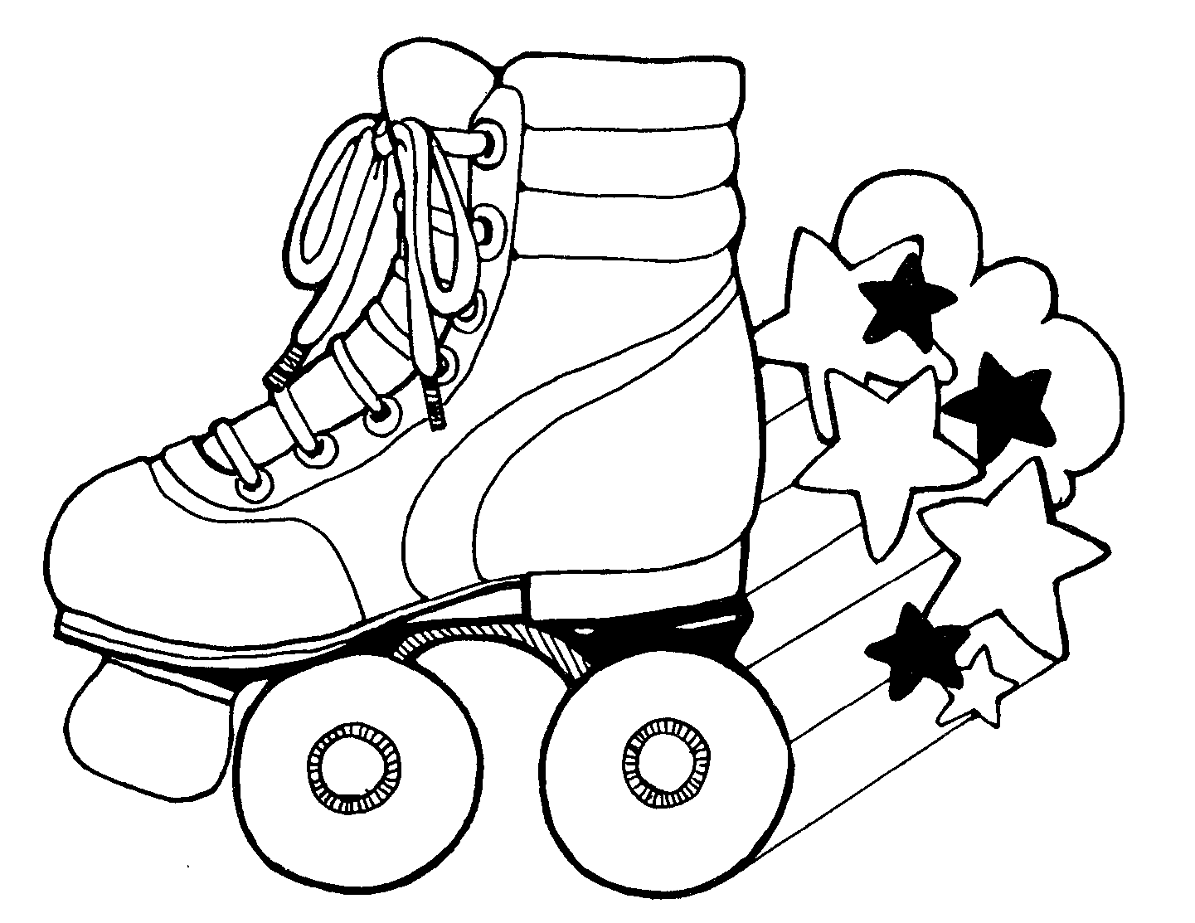  Teen Travel: Hyde Park Roller Magic  Special Activity  for Younger Campers | 12  Pizza Friday  Color Wars!
15  Teen Travel: Hudson Valley Renegades  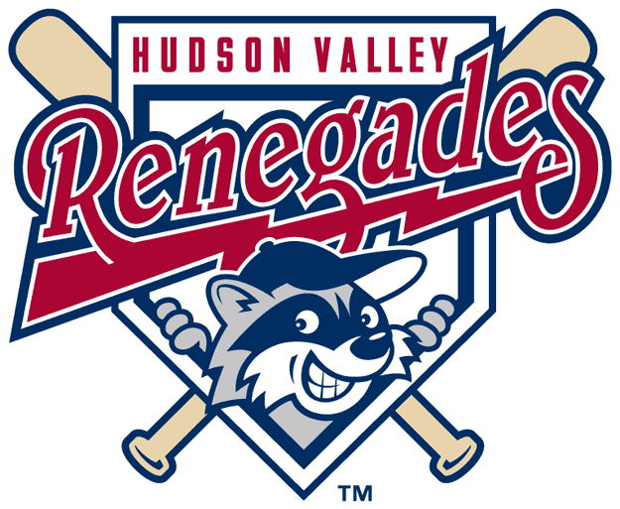  Special Activity for Younger Campers | 16 | 17 | 18  Jersey Day    Pizza Thursday | 19  Parent Day: Carnival  (Lunch will be provided: hamburgers & hotdogs)  
22 | 23  Twin Day   | 24  Wet and Wild Day!  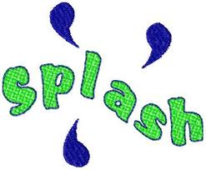 | 25  Teen Travel: The Castle  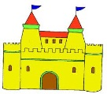  Special Activity for Younger Campers | 26  Pizza Friday    Olympics
Putnam Valley Day Camp Activity Calendar August 2013
Monday | Tuesday | Wednesday | Thursday | Fun Friday
29 | 30  Teen Travel: Canopus Lake @ Fahnestock State Park    Special Activity for Younger Campers | 31 | 1  Crazy Outfit Day   | 2  Pizza Friday  Halloween  
5 | 6  Superhero Day  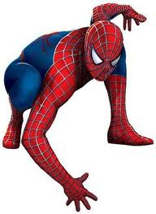 | 7 | 8  Teen Travel: Splash Down  Special Activity for Younger Campers | 9  Pizza Friday  Parent Day: PVDC Play  
12  Disney Dress Up Day  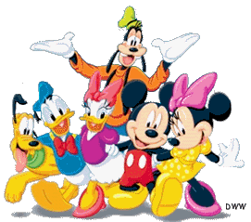 | 13 | 14  Camp Luau   | 15 | 16  Pizza Friday

